

**Concordium — A Brief Summary of what it is about.**

Concordium, positioned as a layer-1 blockchain, establishes the foundational framework upon which decentralized applications (DApps) can be constructed. Some of its distinctive attributes differentiating it from other blockchains are outlined below:

**Stable Transaction Fees**

Concordium ensures predictability in transaction fees. Users engaging in transactions on the Concordium blockchain can expect consistent and unvarying fees. This predictability facilitates effective budget planning, as users are assured that fees will remain constant.

**Integrated Identity Layer**

An intrinsic identity layer is incorporated into the core protocol of Concordium. This layer facilitates the identification of account holders, particularly during official investigations. It establishes a secure linkage between digital wallets and real-world identities, employing third-party verification mechanisms and intelligent zero-knowledge proofs. To engage with Concordium in any capacity, individuals are mandated to undergo third-party verification, fortifying the overall security infrastructure.

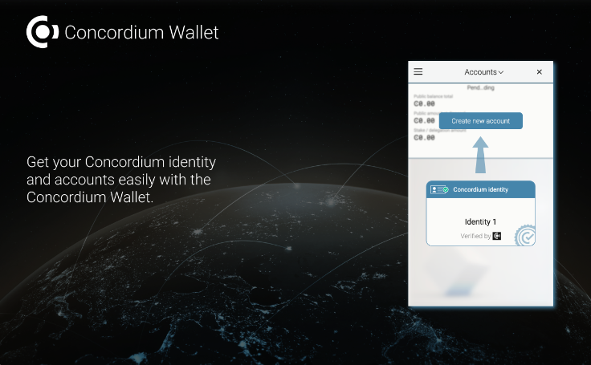

**Blockchain Trilemma Resolution**

Concordium undertakes continuous efforts to address the blockchain trilemma encompassing decentralization, security, and scalability. The platform is committed to achieving equilibrium in these three critical aspects to ensure the system’s safety, optimal functionality, and the capability to handle a substantial volume of transactions.

**Regulatory Compliance and Accountability**

Concordium places a strong emphasis on adherence to privacy regulations and security standards, thereby facilitating confidential and secure transactions. The embedded identity layer plays a pivotal role in establishing accountability, enabling the traceability of any illicit activities occurring on the platform.

**Enhanced User Experience**

Concordium boasts a user-friendly interface designed to facilitate the onboarding of new users through multiple channels, including mobile, browser, and desktop platforms. This inclusive approach caters to diverse user preferences, ensuring a seamless and accessible experience.

**[1 March 2024](https://youtube.com/shorts/TVX0sWjK8d0?si=VmbVi51DAO4GHnb7&source=post_page-----55a99b9bab6b--------------------------------" \t "_blank)**

[youtube.com](https://youtube.com/shorts/TVX0sWjK8d0?si=VmbVi51DAO4GHnb7&source=post_page-----55a99b9bab6b--------------------------------" \t "_blank)

In conclusion, Concordium is carving a distinctive niche in the realm of blockchain and digital transactions in pursuit of excellence. Its unique perspective, rooted in principles of trust, privacy, and safety, aligns with the overarching mission of fostering a secure digital ecosystem. Concordium endeavors to empower individuals and organizations, unlocking the vast potential inherent in blockchain technology.